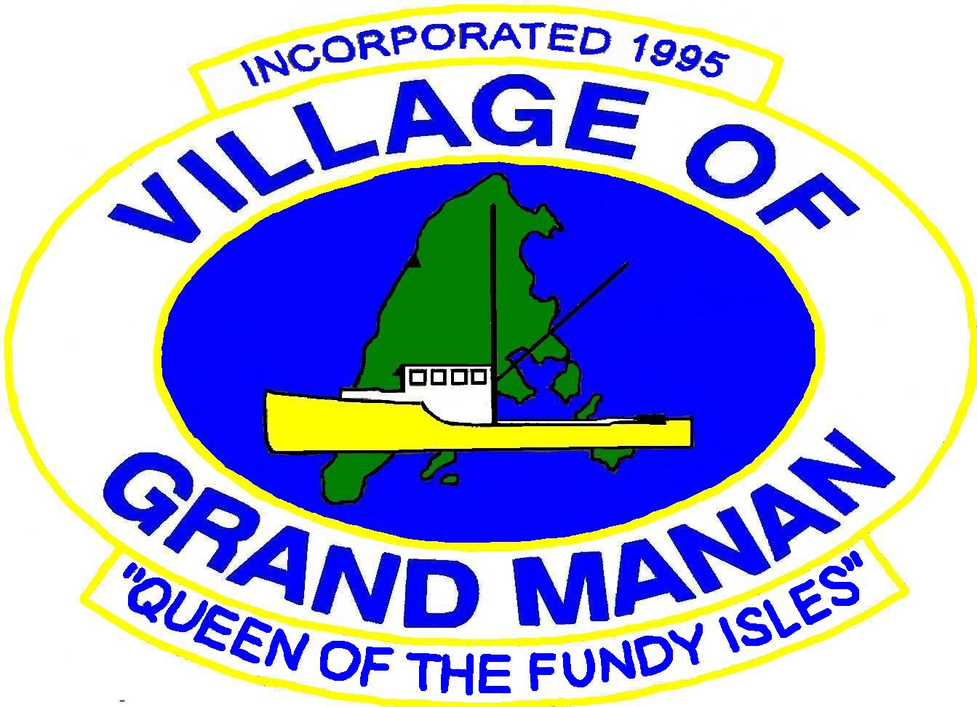

Village of Grand Manan
Facebook Page Local Business Promotion Application

Please fill out the form completely and accurately as we will use the information provided to promote your business on our Facebook Page. One Island business will be shared on the Village’s Facebook Page daily (Mon-Fri) on a first come, first served basis. Submit your completed application via e-mail to gmvc@nbnet.nb.ca

Name of Business:

Services/Products Offered:

Location/Address:

Website/Facebook Page:

Phone Number/Email:

Please include one photo of your business/logo/product/etc. if you wish so we may include it in our post.

