New Brunswick’s Best Kept Secret Vacation Spot
We are all very familiar with the term vacation, as it refers to a time of rest from work or studies. Another definition is: “freedom or release from duty, business, or activity”. Often times though this temporary bit of release ends up costing a great deal of money, which prompts us to work harder to pay off the debt, which in turn increases stress and the need for another vacation. So in essence some vacations only end up adding tension instead of relieving it. For anyone looking to truly down-load all of the worries and anxiety of their day-to-day lives I am going to suggest they stay close to home in New Brunswick’s best kept secret vacation get away, Grand Manan Island.
Grand Manan gets its name from a corrupted pronunciation of a Passamaquoddy first nations word, “mun-an-ook” or “people of the island place” and is the largest island in the Bay of Fundy. This Queen of the Fundy Isles is home to less than 3000 permanent inhabitants and is an idyllic vacation destination for anyone wanting to rid themselves of the stress and hustle of their daily lives. Not long after disembarking from the ninety minute ferry ride from the mainland the absolute peace and tranquility of this Fundy oasis will settle into every fiber of your being. The first thing the intrepid traveler will notice, once the ferry has discharged it’s cargo, is the almost complete absence of traffic. This makes Grand Manan a cyclists paradise. The posted speed limit on the island never gets above 80 kph and the roads for the most part are tolerably level. For hard core cyclists who want to give their legs a really good workout, there is always the winding road up to the Whistle fog horn station and down to the nearby shore or the trip back up from Dark Harbour.
For those interested in hiking and getting up close and personal with the flora and fauna of the island there is a series of some 18 trails that traverse and circumscribe the shores and neigbouring islands. These range in length from a mere 30 minute walk to an overnight trek. And what island would be complete without a light house. Grand Manan boasts a light house trail that takes the visitor to nine current and former light house sites. Some of these sites like Machias Seal Island and Gannet Rock are accessible only by boat and are part of the island boat tours run from the North Head Wharf.
Another segment of the eco-tourism concept of a Grand Manan vacation is the popular whale watching tours. Piloted by seasoned and knowledgeable captains, the mainlanders are treated to sightings not easily experienced without these expert guides. Summer in the Bay of Fundy finds schools of minke, finback and the endangered Atlantic right whale. Along with the whales there are also schools of porpoise and the grey seals that inhabit the rocky shores of the bay and the scores of sea birds nesting at places like Gannet Rock and the Castalia marshes to name just two. If however, you are one prone to sea sickness, fear not, the Grand Manan Whale and Seabird Research Station in North Head offers educational displays of all the local inhabitants of the sea and air currents that surround the island. Likewise the Grand Manan museum in Grand Harbour has an impressive collection of birds on display, not to mention a unique collection of local historical artifacts including a horse drawn hearse.
If you think you can spend your vacation time roaming round a shopping mall on the island much the same as you would in all larger centers in the country, think again. Grand Manan is blissfully devoid of such places. There are however numerous shops offering a wide variety of crafts and island mementos. Artists and artisans abound on Grand Manan with gifts to suit every taste. Painters and photographers, jewelry makers and people with an eye to fashioning works of art from discarded wood and metal objects are just some of the quaint yet impressive skills found among this relatively small population.
No matter where you choose to stay on the big island you will meet it’s greatest ambassadors, the people. The people on Grand Manan are friendly and talkative but not in a nosey prying way, they are just down home friendly. You can expect waves from locals sitting by the side of the road or passing you going in the opposite direction on Route 776, the island’s main drag. From the Whistle to Southwest Head; and all points in between; the friendliness of the natives disarms the visitor and everyone talks to one another like they have been friends for life. Whether you stay in one of the islands many rental cabins, a 19th century home converted to a B&B, an RV campground or the rustic wilderness sites at Hole-in-the-Wall, the real feeling of total relaxation won’t hit you until after dark. From the cliff top camping sites the visitor is overwhelmed by the sheer number of stars visible in the night sky; a sight rarely seen if you live in or even close to a larger urban center. And the peace and quiet, occasionally interrupted by the sound of a breaching whale, is the most completely relaxing thing you will ever experience. It is advisable to at least on one morning of your stay to get up early and watch the sun rise over the eastern horizon. The countless shades of bright reds and oranges that set the sky aflame will astound you.
And one more thing; if you forgot to leave your cell phone, tablet or i-pad home, do yourself a huge favour and toss it overboard right after leaving Black’s Harbour. Remember, you came here to decompress, relax and forget about the world. Don’t let the world nip at your heels while you are trying to ignore it for a short time.
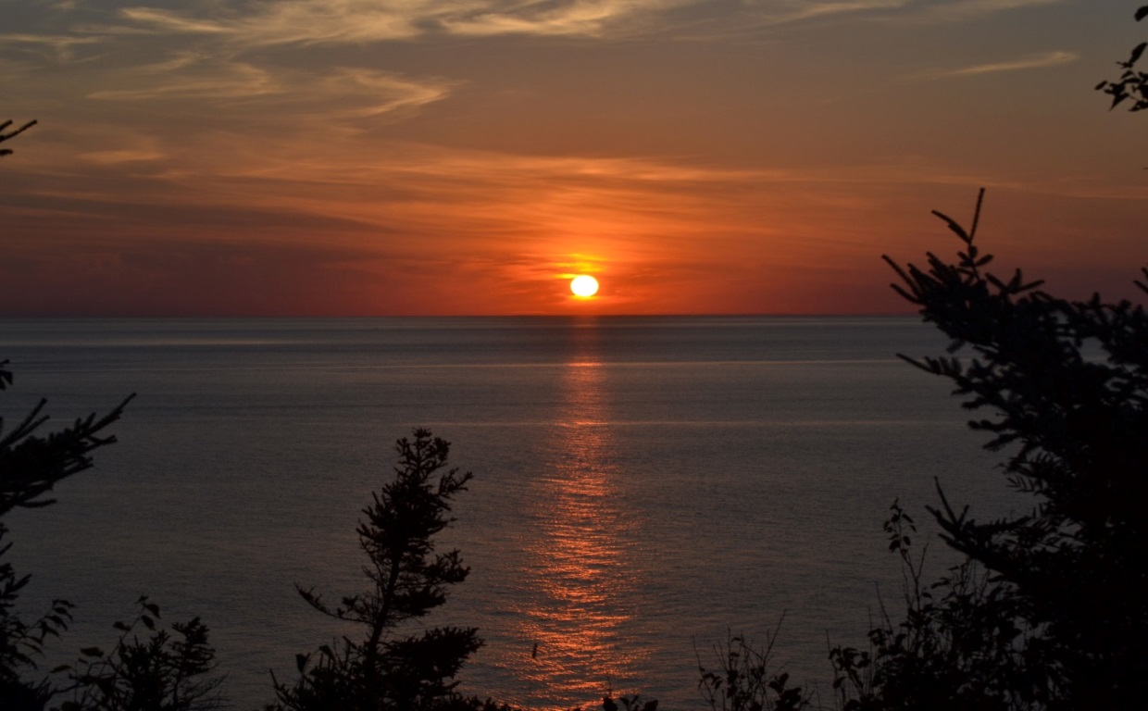
Sunrise at Hole-in-the-Wall

