COMMUNITY GRANT PROGRAM

Chapter VII – Village Grants
(as per Village Policy Manual)

SECTION 1 – NON-PROFIT ORGANIZATIONS

1. General

i. Village of Grand Manan grants are gifts to individuals, non-profit groups or organizations whose majority of members are resident in the Village, for a particular purpose and may be either budgeted or unbudgeted in nature and provide direct benefit to the island residents.

2. Definitions

- Unbudgeted - Is a discretionary unforecasted financial gift to a maximum of two hundred dollars, granted upon the recommendation of a Committee or Council, to an individual, organization or group which provides a service of benefit to the Village and can demonstrate a need for financial aid.

- Budgeted - Is a discretionary gift, either financial or of service in kind as allocated by Council annually within the Village’s budget, and granted to a group or organization which meet at least two of the following:

- provides direct assistance to or complements a Village program or provides a service that, if not provided by the group or organization, would have to be provided by the Village;

- provides a service of benefit to the community;

- demonstrates a need for financial aid.

3. Procedure

- Public Notices - Prior to the budgeting process, the Village Clerk advertises locally that applications for a new/increased grant are available from the Village Office.

- Renewal of a Current Grant - For current grant recipients the Village Treasurer sends a letter requesting a copy of their operating budget for the upcoming year and a current annual report, and informing them that the completion of the grant application form is not necessary, unless an increase in funding is being sought where upon a full application shall be required.

- New/Increased Funding Request - Applications for new/increased funding on the prescribed form are considered only during the budgeting process each year and must be received by the advertised deadline for Council’s consideration.

- Supporting Documents - Applications must be accompanied by:

- a copy of the current operating budget;

- a copy of the operating budget for the upcoming year;

- a report of the previous year’s activities (Annual Report will be accepted);

- a report on the programs/activities proposed for the upcoming year.

- disclosure of other funding sources being pursued.

v. Eligible Expenses - The grant must be applied to a specific program or service, or used as capital funding for the construction of facilities or the purchase of equipment, which will be of benefit to the community at large.

4 Notification of Funding

i. Following adoption of the Village’s Annual Operating Budget, applicants are notified in writing by the Treasurer as to whether they have been awarded a grant.
COMMUNITY GRANT PROGRAM

Application

Applicant’s Details

Organization’s Legal Name

Address

Contact Person:

Home Phone No. Work Phone No. Fax No.

E-Mail Address Total Grant Requested Non-Profit Registration #

Brief Description of the Project
Please check one
- New Application
- Increased Funding Application

Position:

Brief Description of the Project (continued)

Please identify other contributions applied for:

Program | Amount
1.
2.
3.
4.

Is the organization local, or is it a branch of a provincial, regional or national organization

Declarations:

I hereby certify that the information included with this application is complete, and is true and correct to the best of my knowledge, and that I have been authorized by the Board of Directors to make this declaration and to submit this application on behalf of the above named organization.

__________________________ ____________________ ______________
Signature Position Date

I hereby declare that if our organization is successful at obtaining a Village of Grand Manan grant that we give the Village the right to review the project/program for which the grant was obtained to ascertain whether grant monies received were used for the stated purpose(s) set out in this application.

__________________________ ____________________ ______________
Signature Position Date

Application Checklist

Please supply the following additional information

Submitting the Application

- The completed application must be received by the Village Clerk no later the last day of October.

- Late or faxed applications may not be accepted.

- Applications must be clear and legible.

- Please do not submit your application bound, in display folders or plastic sleeves.

- Please ensure all questions are answered on the application form. An application, which is incomplete, may not be considered.

Completed Applications should be sent to:
Office of the Clerk
Village of Grand Manan
4-1021 Route 776
Grand Manan NB
E5G 4E5

For further information please contact:
662-7059 (telephone)
662-7060 (fax)

Failure to comply with any of the above may only delay the processing of your application. Please be specific where asked.
- A copy of the current operating budget

- A copy of the operating budget for the upcoming year

- A report of the previous year’s activities (Annual Report will be accepted)

- A report on the programs/activities proposed for the upcoming year.

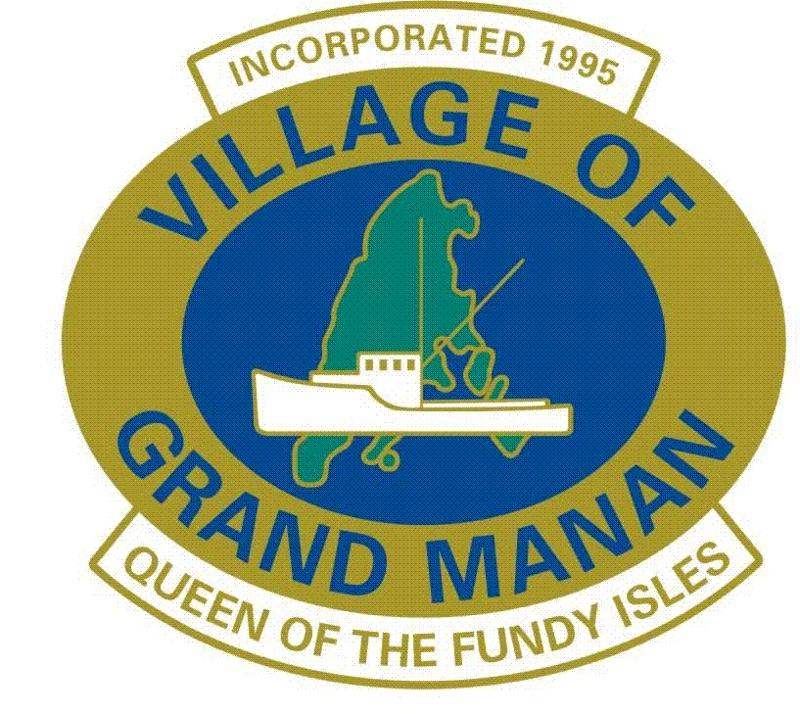
Community

Grant

Program

Guidelines, General Information and Application

Closing Date for Application

31 October

All correspondence should be addressed to:

Office of the Clerk

Village of Grand Manan

4-1021 Route 776
Grand Manan NB
E5G 4E5

Further information and application forms may be obtained by phoning Village Office at 506-662-7059

Village of

Grand Manan

